25 Bridge Building Tips
By Garrett Boon on January 2, 2006 -- Modified on February 4, 2017
Home » Building • Design » 25 Bridge Building Tips
1. Humidity affects the weight of your bridge. Keep your bridge in a closed container with a few grains of rice. or some silica gel packets.
2. Go easy with the glue bottle. As a general rule of thumb, if you can see it then you are using too much.
3. Keep your hands clean! Oils and grease from your skin can ruin your glue joints.
4. Perfect practice makes perfect. The more bridges you build, the better your construction skills will be.
5. Keep your bridge from twisting by using lateral bracing.
6. An L-beam is more efficient than a square, but harder to build.
9. It’s still true, measure twice and cut once.
12. Always keep safety in mind when using sharp tools. Most mistakes are made when you aren’t paying attention.
13. By cutting a piece in half, you more than double its strength in compression.
14. Good lighting when working will help you perfect those little details.
16. Draw out your bridge on graph paper to make sure that it is symmetrical.
17. Different trusses have different ways of spreading out the load.
18. Wood has about the same strength in tension, no matter how long it is.
19. CA glue is a fairly strong, light, fast-drying glue used by many builders.
20. Balsa wood sands very easily. Be careful not to sand off too much.
22. Remember to close your glue bottle when you are done using it.
24. Use Lap joints whenever possible to get the best strength.
25. What you want to look for in glue: drying time, price, weight, and strength.
These bridge building tips will give you a head start when you start designing and building your model bridges. These tips come from my years of experience starting from my time in the Science Olympiad competition and continuing beyond building for fun. Disclaimer: these tips are my own opinion based out of my experience. Other builders might have different views and we might not agree. I encourage you to try things out on your own and decide for yourself what is the best way to build a bridge. Who knows, I could have been wrong about something.
https://www.garrettsbridges.com/building/25-bridge-building-tips/

Lateral Bracing: Key to model bridge strength
By Garrett Boon on December 25, 2006 -- Modified on October 8, 2016
Home » Design » Lateral Bracing: Key to model bridge strength
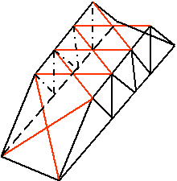
Lateral what, you ask? If you don’t know what this is, you aren’t alone. In fact, it took me quite a while to understand how important lateral bracing is to the success of a model bridge, especially when striving for high strength or efficiency.

Definition of lateral bracing
Lateral bracing is the term we use to refer to any pieces on a bridge that help keep the sides (trusses) from twisting. It also helps keep the top chords of the bridge from bending or deforming in or out. In the figure above, the lateral bracing is marked red.
More examples:
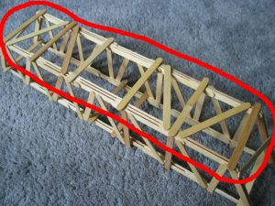
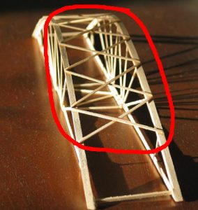

Why is lateral bracing so important?
The shorter a piece of wood, the more compression it can hold before failure. Lateral bracing serves to break the top chord into smaller sections, giving it more strength. It does this by keeping the top chord from twisting or bending. The purpose is similar to that of the main trusses, but it isn’t quite the same. While the truss experiences a lot of force any time the bridge is loaded, the lateral bracing only experiences forces when the top chord starts to deform (twist or bend). Then, and only then, does it come into play.
This is why in a typical model bridge, the lateral bracing pieces are much smaller than the truss pieces. However, don’t let this make you think that lateral bracing is less important, because it is still very critical.
Lateral bracing allows you to make the size and shape of the top chord smaller and oriented to the main downward force. For instance, often in model bridges the top cord is a rectangle piece, with the larger side of the rectangle parallel to the truss. This makes sense, because this orientation allows the top chord to resist force downward. Instead of increasing the small side of the rectangle to resist bending, we add the lateral bracing. When done correctly, this decreases the overall mass of the bridge while still keeping the strength. This in turn, increases the efficiency of the bridge.
Another important job for the lateral bracing is to connect the two sides of the bridge together, and keep them parallel to each other. The latter of these two things is also very important for sharing the overall load on the bridge equally between the two sides of the bridge. If the sides of the bridge get out of whack from each other, the load sharing goes down and one side will fail prematurely.

Why only on top?
Usually we only see lateral bracing on the top of the bridge, and maybe on the two openings for traffic to pass through. This is because the top chords of the bridge are being compressed, but the bottom chords are being pulled in tension, and they are not going to bend or twist in the same way as the top chords will. When you push something it tends to bend or deform. The bottom of a model bridge doesn’t need lateral bracing because they aren’t twisting or bending in the same way. Only the top chords need the extra support to stay straight.
Advanced:
Sometimes based on how the bridge will be loaded, lateral bracing is added to the bottom chords to give extra stability to the loading area.

The shape or design of lateral bracing
Lateral bracing can be done a number of different ways.
- X Shape
- Zig-Zag
- Truss (Warren, Pratt or Howe)
- Any shape that makes triangles
The key, like designing a truss, is making triangle shapes.
An X shape for lateral bracing is beneficial because the x’s make the top chords into a series of triangle shaped sections. Triangles are the go-to shape when building structures, especially model bridges. The triangle is really good at resisting being deformed, which is the whole point of lateral bracing. You could make a zig-zag pattern across the top instead of a series of x’s if you are trying to save some weight or materials.
Advanced:
There is a place and time when you can use straight pieces for lateral bracing instead of X’s. That idea is illustrated by the Fernbank Bridge. Notice that this bridge uses an L-beam for the top chord. And a large L-beam at that. The key lies in that fact; the straight pieces across the top had a very large surface area joining them to the top chord. This automatically made them stiff, and able to resist deforming. This is imitating what a triangle does, and worked very well for the Fernbank Bridge. This idea will not work unless you have the large surface to glue the lateral bracing to the top chords, so be careful if you decide to try it out.

How much lateral bracing do you need?
The amount of lateral bracing you need to use is based on the shape of your top chords. The top chords are most often rectangle shaped, with the skinny side facing up and down and the wide side facing horizontally. A rectangle shaped piece of wood is easy to bend in one direction, but not in the other. If your top chords are rectangle shaped, remember this and use enough lateral bracing to keep the top chords from bending in or out.
Other shapes for top chords are square, T, L, or I beams. The square is probably the least efficient, but is the easiest to manufacture. If you want to use an T, L, or I beam on your model bridge, chances are that you will have to make it yourself by gluing two or more pieces of wood together. These types of beams will need less lateral bracing. However, they are tricky to make and you need to be precise and accurate when you make them. Otherwise they won’t work well.
Generally, most bridges don’t use enough lateral bracing.
Lateral bracing is supporting less of a load than the truss members, so the pieces used for lateral bracing can be smaller. See this Science Olympiad bridge for another example of small but very effective lateral bracing.

Bridge Joints
By Garrett Boon on October 18, 2005 -- Modified on August 20, 2016
Home » Building » Bridge Joints
The type of joint you use on your bridge can drastically change its strength. There are three basic types of joints, the Lap Joint, End Joint, and Notched Joint. To increase the strength of an end or notched joint you can add a Gusset. Learn about each type of joint and when to use it on a model bridge in this article.
These pictures are not of glued joints, I simply laid sticks together. On a bridge, you want to make sure that the joints are clean and there are no gaps between the wood. Glue does not work well as a filler, the two pieces of wood should have no gaps.

Lap Joint:
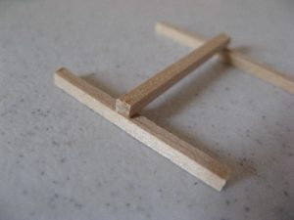
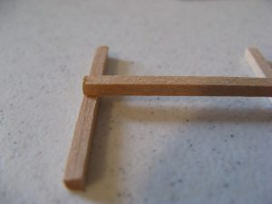

The lap joint is one of the strongest, and you should use it whenever you can. It helps members in compression to resist bending. The lap joint has a potential weakness, however. Depending on the type of glue you use, the joint is only as strong as the face of the wood. If your glue soaks into the wood then this will not be a problem. The face of Balsa wood is typically not strong, and tears easily. You can also help avoid tearing by making sure your lap joints have plenty of surface area for the glue.

End Joint:
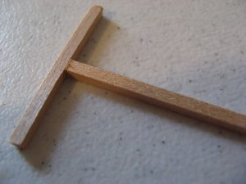
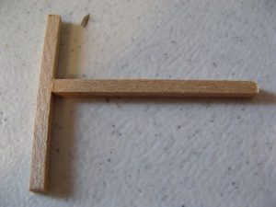

The end joint is not a very strong joint, especially for tension members. In tension, the two pieces of wood will just pull right away from each other. In compression, this joint will allow the piece to bend in a perfect arc. The lap joint holds the piece stiff, which does help it to hold more.

Notched Joint:
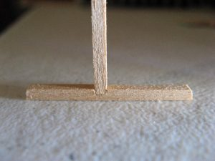
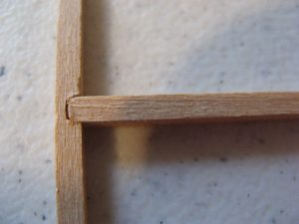

The notched joint gives more strength than the end joint, but less than the lap joint. And if the notch is a little too big, it creates a weakness in the notched member. It is also more difficult to build, which makes it not very common.

Gussets:
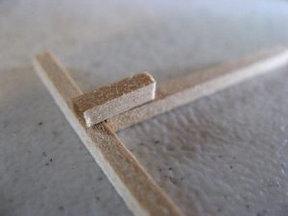
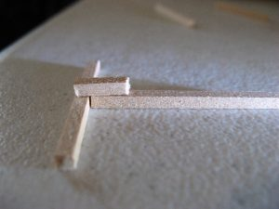

Sometimes it is impossible to avoid using an end joint on your bridge. But you can add a gusset to get all the benefits of a lap joint. In fact, you can make two gussets to create the strongest joint possible.
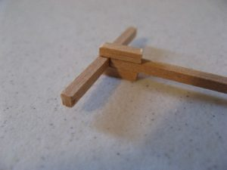
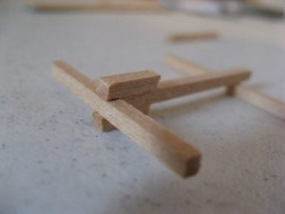

Typically gussets are thin pieces of wood, and not as thick as in these photos. Again, I was simply throwing together some scrap sticks of wood to get these pictures.

Protection
Some of the most common injuries people experience with glue guns are skin burns, electrical shock and eye injuries. Wearing protection can help eliminate these injuries. Wear safety goggles/glasses to protect against eye injuries. Wear a surgical or dust mask over your nose and mouth if you’re using a type of glue (usually industrial) that gives off fumes. Gloves can be worn to protect against burns, but make sure you use the right kind of gloves. Rubber or plastic gloves can melt, which can potentially lead to an even more serious injury if hot glue comes in contact with them. Leather and canvas are better options. Long sleeve shirts, closed-toe shoes and long pants if you’re sitting down working. Finally, tie back any long hair while working with hot glue guns.
While you’re working
Most importantly, do not touch the hot nozzle or hot glue when working with your glue gun.
Never point the gun in the direction of another person.
Do not leave your glue gun plugged in and unattended – this can be a fire hazard and be dangerous for pets, children or other people who may come in contact with the hot appliance.
When not using the gun, make sure to set it down upright on its metal rack, instead of lying on its side.
If you’re using a dual-temp glue gun, you can change the temperature of the glue depending on what materials you’re using. If you need a stronger bond with materials like ceramics, leather, metal or wood, use a higher heat, but if you’re using more fragile materials like paper, flimsy fabric or lace, leave it on a lower heat setting.
Only use glue sticks that are recommended for your particular glue gun.
Don’t pull glue sticks out from the glue gun once the gun is plugged in and glue has begun to melt. Always keep feeding glue through the gun before inserting a new stick in behind it.
.
When you’re finished
Always unplug the gun when you’re finished with your project or when you need to change the nozzle on your glue gun. With most glue guns, the gun is on and hot whenever it is plugged in, so never leave it plugged in and unattended.
In case of a burn
If you get hot glue on your skin, hold the burned area in ice water. If there is a serious burn, contact a medical professional immediately. Medical attention should also be sought if glue makes contact with eyes.

